WATER SECTOR TRUST FUND
Up-scaling Basic Sanitation for the Urban Poor (UBSUP)
Establishing the Project Task Team &
the Detailed Work Plan for SafiSan Projects
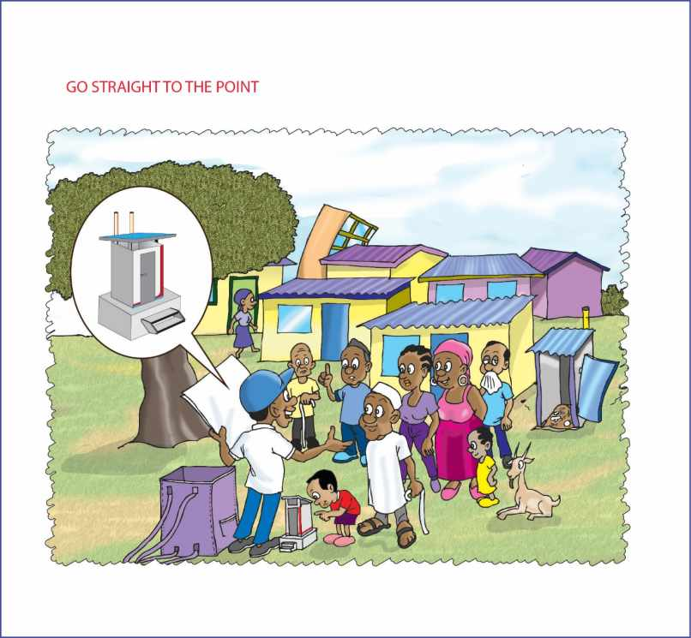
Illustration by Vincent Nyalik

Prepared by the UBSUP Team

Table of Contents
1. Introduction 3
2. Key Activity: Creation of the Project Task Team 3
Why having a Project Task Team? 3
Composition of the Project Task Team 3
Roles of Stakeholders: 1. Project Implementation 4
Main roles and responsibilities of the Project Task Team 5
Coordination 5
3. The Detailed Project Work Plan 5
4. Main activities that constitute the detailed Project Work Plan 5
5. Implementing the detailed Project Work Plan 8
Careful planning of all activities 8
Meetings of the Project Task Team 8
6. Example of a detailed Project Work Plan 8
7. Activity CARDS 8
8. Reporting Activities 8
9. The SafiSan Computers 8
List of Acronyms 9
Appendix 1: Terms of Reference for the Project Task Team 10
Appendix 2: Example of the detailed Project Work Plan 11

Introduction
This document discuses two closely related issues (or “tools”) that are of crucial importance to the successful implementation of the SafiSan projects:
- The Project Task Team
- The detailed Project Work Plan.
The Project Task Team is directly responsible for the (successful) implementation of the SafiSan project. One of the initial tasks of the Project Task Team is the preparation of the detailed Project Work Plan

Key Activity: Creation of the Project Task Team

Why having a Project Task Team?
The main reasons for establishing a multi-stakeholder Project Task Team can be summed up as follows:
- To enable the SafiSan project to make use of all existing expertise at local level (i.e. town and area).
- To create ownership at the local level.
- To prepare well balanced work plans
- To build capacity at WSP level (i.e. WSP staff learn to work together with local experts and with the community and community members).
- To ensure that all project activities are well prepared and coordinated.
- To monitor progress and address challenges.
- To disseminate information about the SafiSan programme.
- More people can make for a lighter individual workload.
- A diverse team is likely to be more creative (even the box is bigger!)

Composition of the Project Task Team
The composition of a balanced, diverse (in terms of skill sets and backgrounds), effective and efficient (mean and lean) Project Task Team can be as follows:
- Relevant staff members of the Water Service Provider (WSP).
- The WSTF and the WSTF County Resident Monitors.
- The Sanitation Marketers of the WSP.
- The Public Health Officer (PHO).
- The Area Chief(s).
- Relevant Municipal and/or County officials.
- Opinion leaders.
- Representatives of relevant NGOs and CBOs.
- Representatives of residents of the project areas.
- Representatives of local artisans.
- Representatives of manual emptiers.
For it to be indeed effective and efficient the Project Task Team should not consist of more than 15 members.

Roles of Stakeholders: 1. Project Implementation
The main roles and responsibilities of the following key stakeholders during the design, implementation and operation of the SafiSan projects can be summarised as follows:

No. | Stakeholder | General roles & responsibilities | Specific roles & responsibilities | D/I/O ^{(*)}
1 | WSP  (Pro-poor unit or sanitation unit) | Project application, project design, project implementation, project operation, project evaluation | Coordination, training, licensing, quality control, data collection, final inspection of SafiSan toilets, operation of DTFs | D/I/O
2 | WSTF | Funding, awarding, monitoring, capacity building evaluation | Providing support to the WSPs | D/I/O
3 | WSTF County Resident Monitors | Support the WSP, facilitate, build capacity, train, participate in all phases of the project | - Awareness creation and community mobilisation  - Monitoring the work of the Social Animators and local artisans | D/I/O
4 | Sanitation Marketers | Awareness creation and community mobilisation, social marketing, data collection & transfer | - Marketing the SafiSan toilets  - Explaining the local value chain to residents, organising SafiSan Mini Fairs and Baraza Shows | I
5 | Public Health Officer | - Sensitisation & training  - Enforcing health & hygiene-related by-laws | - Communicating health & hygiene messages to the area residents  - Training of manual emptiers | D/I/O
6 | Area Chief | Awareness creation and community mobilisation | Co-organising SafiSan Mini Fairs and Baraza Shows | D/I/O
7 | Municipal & County Officials | Facilitate, enforcement of local by-laws | Identification and procurement of sites for DTFs | I/O
8 | Opinion leaders | Awareness creation, community mobilisation, sensitisation | - Participate in community-level activities  - Use gathering organised by the institution (e.g. church services) to sensitise members | D/I/O
9 | NGOs & CBOs | Awareness creation, community mobilisation, sensitisation | Co-organise SafiSan activities | D/I/O
10 | Community members | Awareness creation, community mobilisation, sensitisation | - Co-organise SafiSan activities  - Ensure that the interests of- and challenges faced by the local artisans are taken into account | D/I/O
11 | Manual emptiers ( Sanitation Teams) | Provide expertise to the Project Task Team | Ensure that the interests of- and challenges faced by the manual emptiers are taken into account | D/I/O
12 | Local artisans | Provide expertise to the Project Task Team | Ensure that the interests of- and challenges faced by the local artisans are taken into account | D/I/O
*): D = Project Design; I = Implementation; O = Operation

Main roles and responsibilities of the Project Task Team
The main tasks of the Project Task Team are:
- Preparation of the detailed Project Work Plan.
- Establishing working relationships with the project areas/communities.
- Community mobilisation.
- Community sensitisation.
- Training the Social Animators.
- Guiding and monitoring the Sanitation Marketers.
- Ensuring the good quality of all technical works (e.g. SafiSan toilets, DTFs, etc.).
- Project monitoring to ensure high quality of works and sustainable operation.
- Disseminating information on the SafiSan project & programme.
- Reporting to the management of the WSP.
- Reporting any irregularities (e.g. cases of theft, corruption, nepotism, etc.).
The more detailed Terms of Reference of the Project Task Team are presented in Appendix 1 of this document.

Coordination
The success of a project that involves a wide variety of stakeholders (residents of the project area, a water company, a Public Health Officer, the local authorities, etc.) in most cases depends on the careful planning and coordination of all project activities (construction works, community mobilisation and awareness creation, social marketing, embedding of SafiSan within the WSP). This not only requires close cooperation between the various stakeholders - especially within the Project Task Team – but it also requires the careful preparation of the detailed Project Work Plan.

The Detailed Project Work Plan
Main objectives of the detailed Project Work Plan
The main objectives of the detailed Project Work Plan can be summed up as follows:
- Ensuring that all project activities, technical, financial and social (marketing) are included.
- Reach an optimal coordination of activities in order to achieve efficiency and effectiveness.
- Make sure that all Project Task Team members and the other stakeholders involved are aware of their tasks as well as of the activities other members and stakeholders are involved in (i.e. transparency).

Main activities that constitute the detailed Project Work Plan
The main activities that could make up a detailed SafiSan Project Work Plan are shown below.

No. | Activity
1 | WSP appoints staff members responsible for onsite sanitation & for SafiSan programme
2 | Project Task Team kick-off meeting (discussion of ToR and prep. Project Work Plan
3 | Preparation of the SafiSan office/desks within the office of the WSPs
4 | Awareness creation (regarding the project) at WSP level (meeting, posters, etc.)
5 | Training of relevant WSP staff on the SafiSan software & toolkit
6 | Capacity development activities (mainly at WSP level) provided by the Field Monitors
7 | Recruitment of the Social Animators (based on area population data & habitation patterns)
8 | Training of the Social Animators
9 | Demand assessment in the SafiSan Project Phase 1 project area (zone)
10 | Confirmation of SafiSan Project Phase 1 project area(s)
11 | Construction of the SafiSan demonstration toilets
12 | Identification of potential SafiSan Project Phase 2 areas (zones)
13 | Preparation of the market research (demand assessment) programme (for Phase 2)
14 | Assess the need for decentralised treatment facilities and site requirements
15 | Identification of suitable & accessible sites for DTFs
16 | Data transfer (Phase 1) to the Virtual Sanitation Tool (VST)
17 | Design of the community awareness > mobilisation > social marketing project component
18 | Preparations for the community awareness & mobilisation programme
19 | Identification and registration of the local artisans
20 | Identification and registration of the manual emptiers
21 | Procure site(s) for DTFs
22 | Identification of DTF operators
23 | Training & licensing of local artisans
24 | Training & licensing of Sanitation Teams
25 | Implementation of the short school WASH programme
26 | Creation of a database on Sanitation Teams
27 | Testing of the entire set of SafiSan procedures (toilet registration, construction, etc.)
28 | Start of the community awareness and mobilisation component (barazas, etc.) (**)
29 | Start of the social marketing component (e.g. household & plot visits)
30 | Data collection & transfer by Sanitation Marketers.
31 | Registration of customers
32 | The WSP makes information on local artisans available to customers and vice-versa
33 | Start of the construction and/or assembly of SafiSan toilets
34 | Project Task Team meetings (when required)
35 | Confirmation of potential additional project areas or zone(s) (sanitation hotspots)
36 | Market study focusing on Phase 2 project areas zone(s)

No. | Activity
37 | Data analysis & confirmation of SafiSan Project Phase 2 project area(s)
38 | Transfer of data to the Virtual Sanitation Tool (VST)
39 | Preparation of disbursement requests (when required)
40 | Signing of memorandum of understanding (MoU) for DTF(s) with the relevant authorities
41 | Start of the construction work on the decentralised treatment facilities (DTFs)
42 | (final) Inspections and data collection on SafiSan toilets (as required) (**)
43 | Rectification works (as required)
44 | Transfer of data to the WSP-SafiSan computer (as required)
45 | Payment of Post Construction Incentive (on-going/as required)
46 | Commissioning of SafiSan toilets (on-going/as required)
47 | Training of the operators of decentralised treatment facility (-ies)
48 | Community sensitisation on the decentralised treatment facility (-ies
49 | Commissioning of the decentralised treatment facility (-ies)
50 | Transfer of data to the WSTF (UPC-IS & MajiData) at regular interval
51 | Updating of the UPC-IS & MajiData (WSTF level) and feedback to WSP & County Resident Monitors
52 | Monitoring the use and maintenance of the SafiSan toilets
53 | Monitoring the emptying of SafiSan toilets
54 | Monitoring sludge management and the operation of the decentralised treatment facilities
55 | Regular reporting and providing feedback (used to improve SafiSan concept & UPC)
56 | Preparation of Phase 2 and other subsequent phases of the SafiSan project

The various project activities can be categorised as follows:
- Design and planning activities.
- Information and training activities.
- Market research (Demand Assessment) activities.
- Data collection activities.
- Social marketing:
- E1. Awareness creation activities.
- E2. Mobilisation activities.
- E3. Social marketing activities.
- Technical activities.
- Preparation of disbursement requests.
- Reporting activities
- Monitoring activities.
The example of a detailed project work plan presented in Appendix 2, uses the codes (“A”, “B”, etc.) to categorise the various project activities.

Implementing the detailed Project Work Plan

Careful planning of all activities
The implementation of the detailed Project Work Plan requires careful planning and the coordination of the various project activities. It has to be emphasised that achieving efficiency requires that certain project activities are implemented simultaneously. Other activities can only be implemented after specific other activities have been completed.

Meetings of the Project Task Team
Careful planning and the coordination of activities should be done during the meetings of the Project Task Team. In addition to organising regular Project Task Team meetings (e.g. the monthly meeting), the Project Task Team, or certain members of the team, should organise (ad hoc) meetings whenever required.

Example of a detailed Project Work Plan
An example of a detailed Project Work Plan is provided in Appendix 2 of this document. This example should not simply be copied by the (your) Project Task Team. Each WSP is different, each project area is different, and indeed each project is different. Therefore, there is need for each Project Task Team to prepare its own detailed Project Work Plan.

Activity CARDS
In addition to the Project Work Plan more detailed information regarding all the key SafiSan project activities are presented in the Project Activity CARDS. These Activity CARDS are part of the Toolkit for Urban Sanitation.

Reporting Activities
The Project Task Team, unless the WSP decides otherwise, does not have to prepare reports (e.g. a monthly progress report). It is likely that the WSP staff participating in the SafiSan project have to report to their superiors (e.g. to the management of the WSPs).
The County Resident Monitors of the WSTF have to submit their Monthly Report to the WSTF. The reporting template has been provided by the WSTF. Finance-, Engineering- and Social Field Monitors each submit their own report. Reports are submitted by e-mail. The WSP receives a copy of the report.
The WSP also has to report on progress and challenges to the WSTF though the submission of a Monthly Report.

The SafiSan Computers
The following software and files will be installed on the SafiSan computer (preferably a desktop computer or a laptop computer with peripherals such as an external keyboard, mouse, etc.):
Software:
- Microsoft Office (2010 or 2013) (including MS-Access).
- Internet Explorer.
- The Virtual Sanitation Tool.
- The Toolkit for Urban Sanitation Projects (DVD).
- The Toolkit for Urban Water Supply Projects (DVD).
- The WSTF Procedures & Information Document (DVD).
- AquaPix 1 & AquaPix 2 (DVD).
- WaterSource.
- SafisApp
Database:
- Social Animators database.
- Manual emptiers ( sanitation teams) database (licensed and not licensed).
- Local artisans database (licensed and not licensed).
- Customer database: registrations, follow-up visits & non-response).
- Toilets database (type, location, quality of works, completeness, hygiene, etc.).
- MajiData (link to the website ( www.majidata.go.ke ).
- Reporting templates (WSP > WSTF and County Resident Monitors > WSTF).
___________________________________________________________

List of Acronyms
CBO: Community-based organisation
DTF: Decentralised treatment facility
CRM: County Resident Monitor
MoU: Memorandum of Understanding
MS: Microsoft
NGO: Non-governmental organisation
PHO: Public Health Officer
VST: Virtual Sanitation Tool
WASH: Water, Sanitation & Hygiene
WSP: Water Service Provider
WSTF: Water Sector Trust Fund

Appendix 1: Terms of Reference for the Project Task Team

No. | Activity | Remarks
A | Design, planning & coordination
A1 | Preparation of the detailed Project Work Plan | See Appendix 2
A2 | Coordination of all project activities | A key task of the Project Task Team
A3 | Making necessary adaptations in the Project Work Plan | When required
B | Information & training activities
B1 | Creating awareness at WSP level (staff)
B2 | Training of Sanitation Marketers
B3 | Training of manual emptiers
B4 | Training of local artisans
B5 | Training of DTF operators
C | Market research (demand assessment)
C1 | Assessing the demand for SafiSan toilets
C2 | Assessing the demand for DTFs
D | Data collection
D1 | Collect data on project areas (zones)
D2 | Collect and analyse data on (potential) customers
D3 | Data entry
E | Social marketing
E1 | Creating awareness at community level
E2 | Community mobilisation & sensitisation | Sensitisation on health & hygiene
E2 | Social marketing | Household & plot visits
F | Technical activities
F1 | Supervision of technical works
F2 | Quality control | DTFs and SafiSan toilets
F3 | Operation (use) and maintenance monitoring
H | Reporting
H1 | Reporting to the WSP (management) | Responsibility of WSP staff
H2 | Reporting to the WSTF | Responsibility of the CRMs
H3 | Reporting any irregularities | To the WSP and/or the WSTF & KACC
I | Monitoring
I1 | Monitoring the overall project progress
I2 | Monitoring the technical works
I3 | Monitoring the Social Animators
I4 | Monitoring toilet use, operation & maintenance
I5 | Monitoring the sanitation value chain | Including DTF operation & maintenance

The WSP or the Project Task Team itself can decide to include other stakeholders in the Project Task Team. For example, in areas where crime levels and/or levels of vandalism and theft are high the local police authority can be requested to participate in the Project Task Team.
A baraza (a Swahili word) is a public meeting.
Each community awareness & mobilisation activity such as the SafiSan Mini Fair and the SafiSan Baraza Show has its own programme.
All DVDs have a user interface.

